Abu Rayhon Beruniy nomidagi
urganch davlat universiteti Kompyuter injinering fakulteti Kompyuter ilmlari va dasturlash texnologiyalari
234- guruh talabasi Odomboyeva Muhayyoning
“Machine learning” fanidan
5-laboratoriya ishi



O’qituvchi:Qurbonova Ruzikajon

Mavzu:Decision tree
https://archive.ics.uci.edu/datasets shu silka orqali bank marketing datasini yuklab oldim zip faylini.

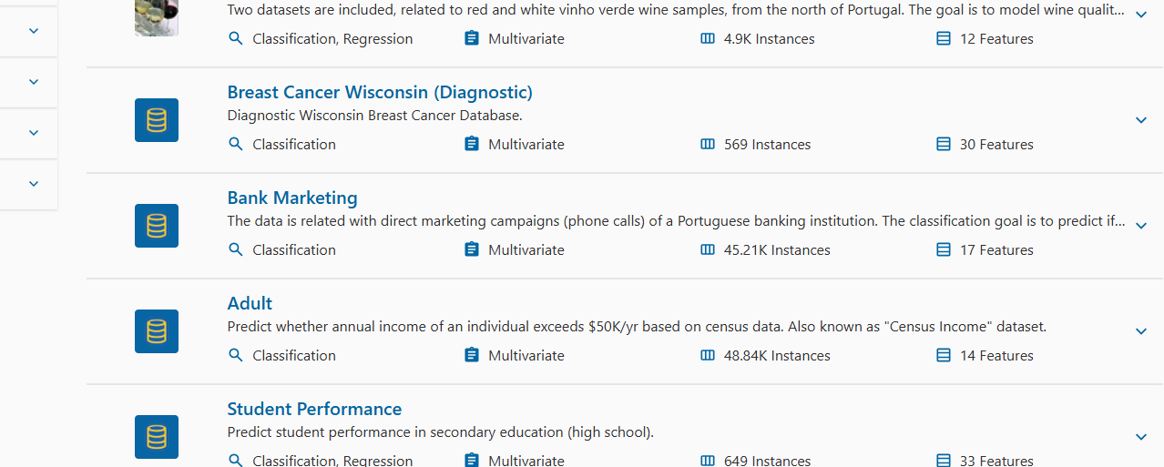
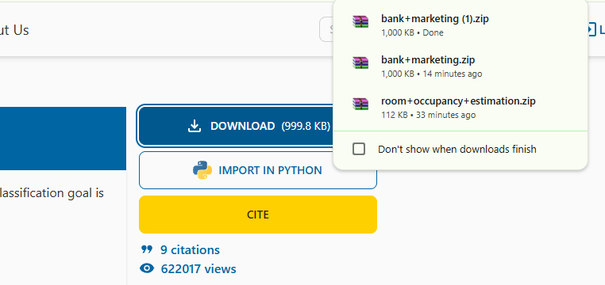

Keyin yuklab olgan faylimni ochdim

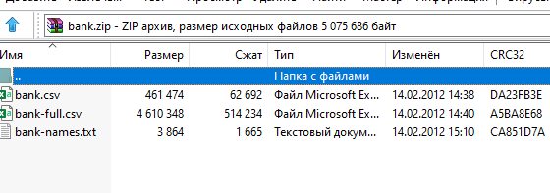

Csv faylni yuklab oldim
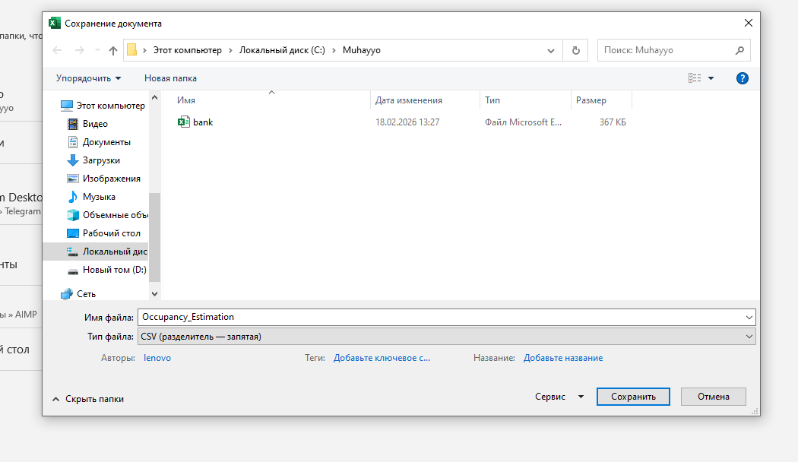

Keyin google collabga kirib quyidagi kodni tashladim
import pandas as pd
import numpy as np

from google.colab import files
from sklearn.model_selection import train_test_split
from sklearn.compose import ColumnTransformer
from sklearn.pipeline import Pipeline
from sklearn.preprocessing import OneHotEncoder
from sklearn.impute import SimpleImputer
from sklearn.tree import DecisionTreeClassifier, plot_tree
from sklearn.metrics import accuracy_score, classification_report
import matplotlib.pyplot as plt

uploaded = files.upload()
csv_name = list(uploaded.keys())[0]

df = pd.read_csv(csv_name, sep=";")

df.columns = df.columns.str.replace("\t", "", regex=False).str.strip()

print("Shape:", df.shape)
display(df.head())

TARGET_COL ="y"
TASK = "classification"

X = df.drop(columns=[TARGET_COL])
y = df[TARGET_COL]

num_cols = X.select_dtypes(include=["number"]).columns
cat_cols = X.select_dtypes(exclude=["number"]).columns

preprocess = ColumnTransformer(
transformers=[
("num", Pipeline([("imputer", SimpleImputer(strategy="median"))]), num_cols),
("cat", Pipeline([
("imputer", SimpleImputer(strategy="most_frequent")),
("onehot", OneHotEncoder(handle_unknown="ignore"))
]), cat_cols),
]
)

X_train, X_test, y_train, y_test = train_test_split(
X, y, test_size=0.25, random_state=42, stratify=y
)

pipe = Pipeline(steps=[
("preprocess", preprocess),
("model", DecisionTreeClassifier(max_depth=4, random_state=42))
])

pipe.fit(X_train, y_train)

pred = pipe.predict(X_test)
print("Accuracy:", accuracy_score(y_test, pred))
print(classification_report(y_test, pred))

feature_names = pipe.named_steps["preprocess"].get_feature_names_out()
tree_model = pipe.named_steps["model"]

plt.figure(figsize=(26, 12))
plot_tree(
tree_model,
feature_names=feature_names,
class_names=[str(c) for c in tree_model.classes_],
filled=True,
rounded=True,
fontsize=7
)
plt.show()
bu kodni ishltaganda pastda choose files chiqadi uni bosib yuklab olgan faylimizni ochamiz
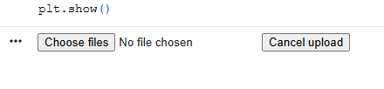
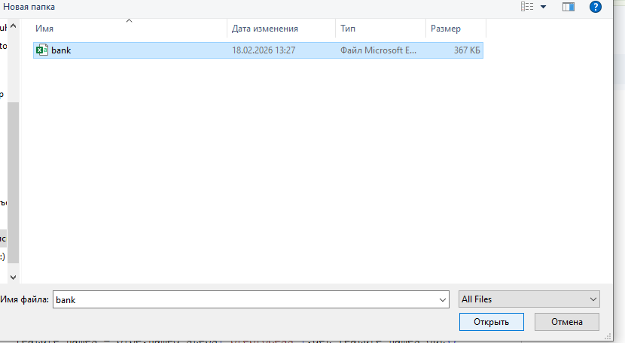
Natijasi quyidagicha chiqadi

